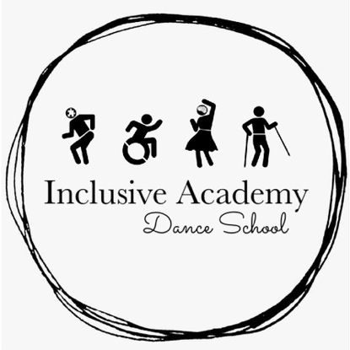
Inclusive Academy Dance
School Enrolment Form

Participant Information
Name of participant: |  | Gender:
Address: |  | Postcode:
Age of participant: |  | Date of birth of participant:
Contact number:  Home:  Mobile: |  | Contact email:

Parent/Guardian Information (Main contact) |  | Emergency Contact (This person will be contacted if main contact is unavailable)
Name: |  | Name:
Address & Postcode (if different from participants): |  | Address & Postcode (if different from participants):
Relation to participant: |  | Relation to participant:
Contact number:  Home:  Mobile: |  | Contact number:  Home:  Mobile:
Contact email: |  | Contact email:

Health/Disability
Please detail anything you feel is important for me to know about the participant (if any). For example, disability, epilepsy, sensory impairments, mental health issues, respiratory diseases or problems, etc.

Is your child a wheelchair user?
Yes | No

What class would you like to join?
Sensory movement class | Accessible class | Advanced class

How would you like to pay?
Please circle which box applies.
Cash |  | Termly
Bank transfer |  | Half termly

Would you like to use our family rate (£2 per additional person per lesson)?
Yes | No | If yes, how many additional people?:

Lastly, how did you hear about Inclusive Academy?

Child photo/video consent form

In accordance with our policies, including safeguarding, we will not permit photographs, videos, or other images of children and young people to be taken without the consent of the parents/carers and the child.

This form explains potential uses of student photographs and video images by Inclusive Academy Dance School and allows you to grant permission for Inclusive Academy Dance School to release your child’s image for display or publication.

Inclusive Academy Dance School uses internal and external media to highlight our experience in a variety of ways, which may include the use of photographs and videos of participants. For example, participant images may be published or displayed in printed materials (such as leaflets and brochures), videos, our dance school website, and our Facebook, Instagram and Twitter pages. Also, for information about the school events and activities provided to external organisations and media outlets.

Your consent choice will apply the whole time you and your child are a part of Inclusive Academy Dance School. Please be aware that images used with your consent may remain in existing publications after you leave Inclusive Academy Dance School.

You can change you consent choice at any time by emailing inclusive.academy@outlook.com or by writing to Inclusive Academy Dance School, 32 Edison Road, Stevenage, SG2 0DG.

Completion of this form indicates your consent. If you DO NOT complete a form, your choice will be recorded as not given and photographs, videos, and other images will NOT be taken of your child.

We recommend you take the time to read through all our current polices which are available on our website https://www.inclusiveacademydanceschool.com/policies

Inclusive Academy Dance School Child Photo/Video Consent Form
Child’s name:
I consent to my child’s image being used for: |  | Tick for yes. X for no.
- Printed material’s (leaflets, brochures, etc.).
- Inclusive Academy Dance Schools’ website.
- Inclusive Academy Dance School’s Facebook, Instagram, and Twitter pages.
- External organisations and media outlets.
- I consent to Inclusive Academy Dance School photographing or videoing my child for the reasons I have ticked above.
- I can confirm that I have read, or been made aware of, the schools safeguarding policy (including the use of mobile phones, cameras, and social media section) and our GDPR policy.
- I can confirm that I have read, or been made aware, of how Inclusive Academy Dance School will use these images/videos in the future and how these images/videos will be stored within the dance school.
Signature of parent/guardian: | Date:

